[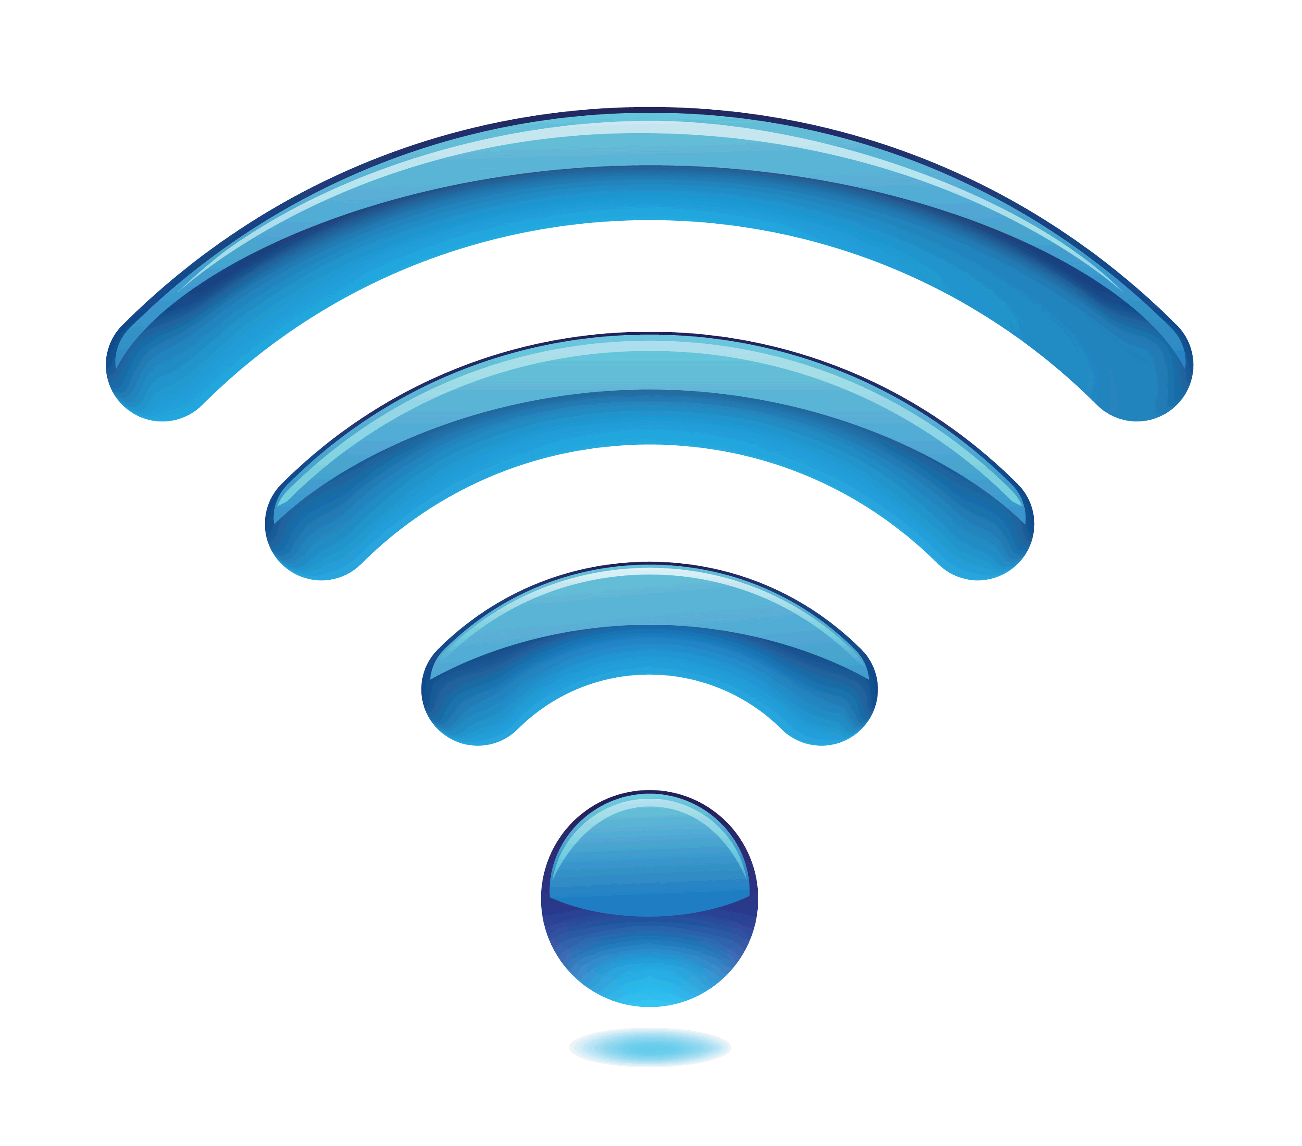](https://www.google.co.uk/url?sa=i&rct=j&q=&esrc=s&source=images&cd=&cad=rja&uact=8&ved=2ahUKEwi1lMbOuPzeAhVQqxoKHcSUAk0QjRx6BAgBEAU&url=https://www.avalan.com/blog/bid/357382/Top-10-Advantages-of-Proprietary-Wireless-Technologies&psig=AOvVaw0NwTsUv2XiSqJNeUwI6mcm&ust=1543678470807841)**Smart lawn water sprinkler node – Raspberry-pi:**

MySQL workbench (cloud server)

Once the data has been sent to the server it will then be stored on this server and database from the http url. For example, rfiddao link would then be stored on this server, which can be used to retrieve the data, from the database.

[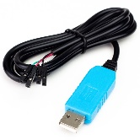](https://cdn.shopify.com/s/files/1/0174/1800/products/USB_UART_1_of_2_1024x1024.JPG?v=1463052664)

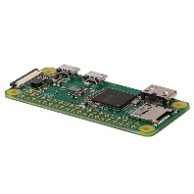

[](https://www.google.co.uk/url?sa=i&rct=j&q=&esrc=s&source=images&cd=&ved=2ahUKEwiB0smq9YnfAhULxoUKHWJJCRoQjRx6BAgBEAU&url=http://lofrev.net/http-logo-pictures/&psig=AOvVaw0jwGeXnhh-zWTzoHDtKrwq&ust=1544141456778068)

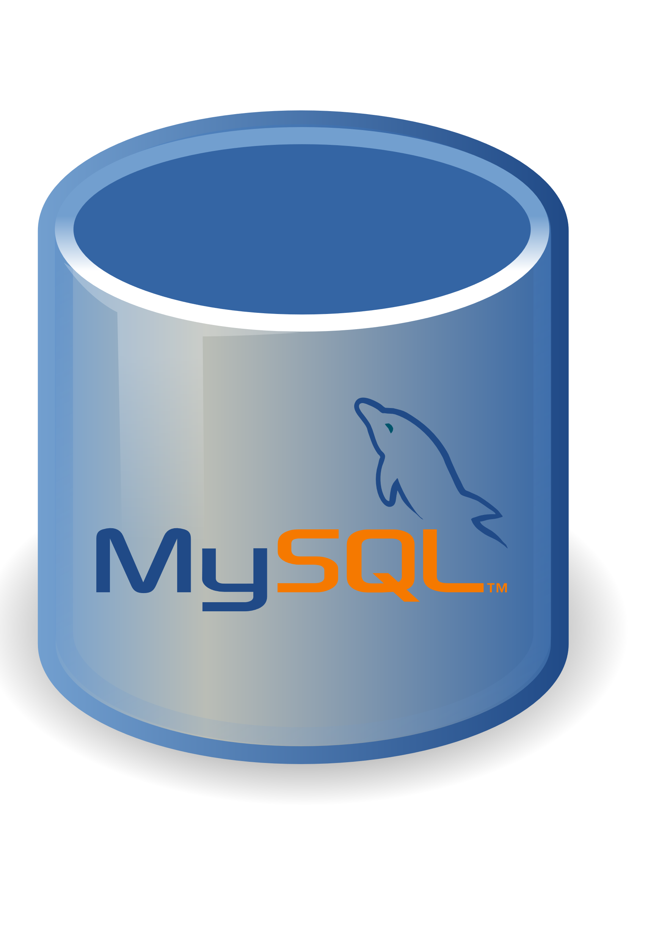

Internet node:

The Internet node is then used to access the url link using http. For example, rfiddao link with the data value, would then send the data to my sql database. Hence, the messages sent to/from cloud server sent via http calls. They would then be stored on the database. The router would then be connected to the internet, using the cloud server.

Raspberry-pi board node

The Raspberry-pi board node is then connected to the node hub using a cable. It would receive data from the Raspberry-pi board and transmits it to the node hub. It would then send the messages to the correct mqtt topic, e.g. topic_motor.



[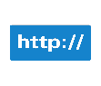](https://www.google.co.uk/url?sa=i&rct=j&q=&esrc=s&source=images&cd=&ved=2ahUKEwiB0smq9YnfAhULxoUKHWJJCRoQjRx6BAgBEAU&url=http://lofrev.net/http-logo-pictures/&psig=AOvVaw0jwGeXnhh-zWTzoHDtKrwq&ust=1544141456778068)

[](https://www.google.co.uk/url?sa=i&rct=j&q=&esrc=s&source=images&cd=&cad=rja&uact=8&ved=2ahUKEwiNw9He84nfAhUFWhoKHWf5CLkQjRx6BAgBEAU&url=https://www.iconfinder.com/icons/198045/computer_connection_data_laptop_network_node_icon&psig=AOvVaw0BcheFI4aQRpPGN5m_M8l9&ust=1544140970422773)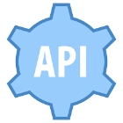

Raspberry-pi board node

Raspberry-pi node is connected to the Light sensor, motion sensor, temperature sensor, Electric Solenoid Valve, through a cable. The sensor network is local only unless theres gateway available.

Water sprinkler node:

The main node hub would be connected to the internet via the router, so it can be controlled on any device through the app.

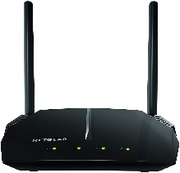

Developer public Api node

The node hub would then receive the data which has been transmitted from the raspberry-pi board. Also, gives gateway for the internet connection.

The messages can be sent to the main hub via cloud server, json format, over http calls if known.



[](https://www.google.co.uk/url?sa=i&rct=j&q=&esrc=s&source=images&cd=&cad=rja&uact=8&ved=2ahUKEwiAjMLW4_LeAhVQPBoKHeA3Bl8QjRx6BAgBEAU&url=https://loinhacviet.info/explore/watering-clipart-lawn-sprinkler/&psig=AOvVaw3GrOA1BamMlfezY5KqfDtI&ust=1543346429554670)

Android phone node:

The android phone would then be able to communicate through the internet to talk to the main node hub. This will then enable the user to remotely control the water from the app. It would allow the user to turn the water on/off. The app will be connected to the cloud server to communicate with the main hub. The app will only communicate via cloud server. No direct connection. One of the security aspects which is important to the mobile device is the fingerprint. The only person which would be able to get into the phone using the finger print is the person who’s phone it is. Password/pin is another security aspect which can be used to keep the phone secured.

Wifi Router node:

The main node hub would then connect to the Wi-Fi to enable the user to use the internet. This would then enable you to view the data on the browser using the url. Also, the main node hub would be connected to the internet via the router, so it can be controlled on any device through the app. One of the security aspects which is important to the router is, every router would have its own unique password and this password need to be kept secure.

Sprinkler Node

* Actuator – moonseed valve, switch to turn the water sprinkler on/off.
* Sensor –sensors such as temperature sensor, light sensor, motion sensor, and water moisture levels.
* Processor – small scale to be compatible for a tinker board
* Power supply
* Protective all-weather case

The app will be connected to the cloud server to communicate with the main hub. It will then allow the user to use the app through wi-fi.

Sprinkler Node

* Control Sprinkler Nodes
* Power supply
* Processor
* Motorised valve
* Router to connect to the internet
* Mobile device